CREATE JAVA APPLICATION

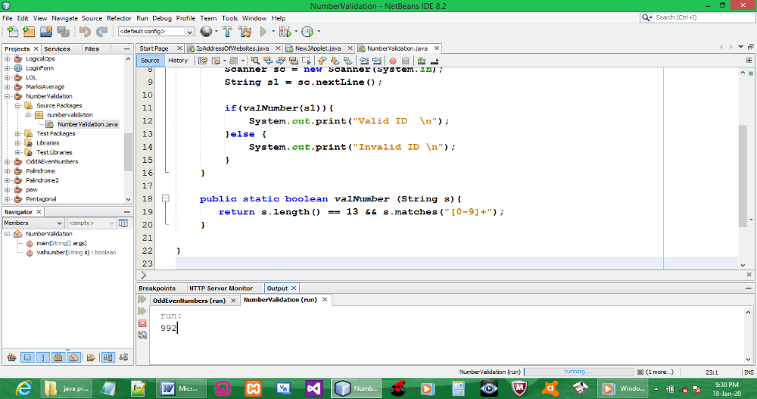

CODE:

package numbervalidation;

import java.util.Scanner;

public class NumberValidation {

public static void main(String[] args) {
Scanner sc = new Scanner(System.in);
String s1 = sc.nextLine();

if(valNumber(s1)){
System.out.print("Valid ID \n");
}else {
System.out.print("Invalid ID \n");
}
}

public static boolean valNumber (String s){
return s.length() == 13 && s.matches("[0-9]+");
}

}

OUTPUT:

